Module -5 Scripting (Python and Bash)

Assignment

- Grade Checker

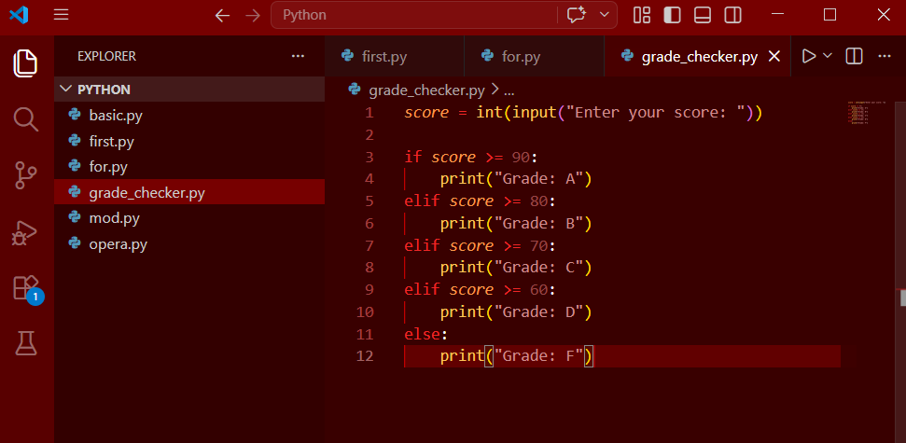

Output
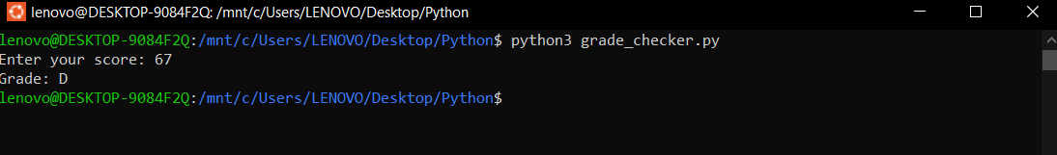

Explantion
This program takes a numeric score as input from the user and uses if-elif-else conditions to determine the corresponding grade. Based on the score range, it prints grades A, B, C, D, or F.

- Student Grades(Dictionary)
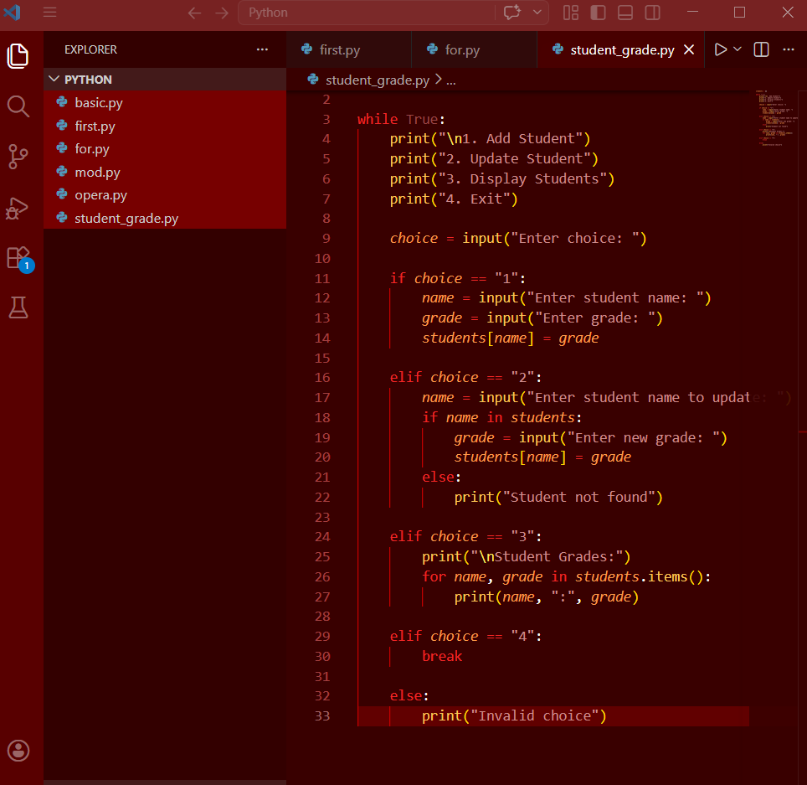

Output
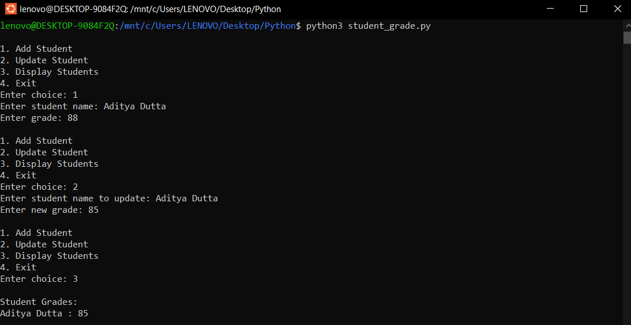

Explanation-
This program uses a dictionary to store student names as keys and grades as values. It provides a menu-driven interface where the user can add new students, update existing grades, and display all records using conditional statements and loops.

- Write to a File

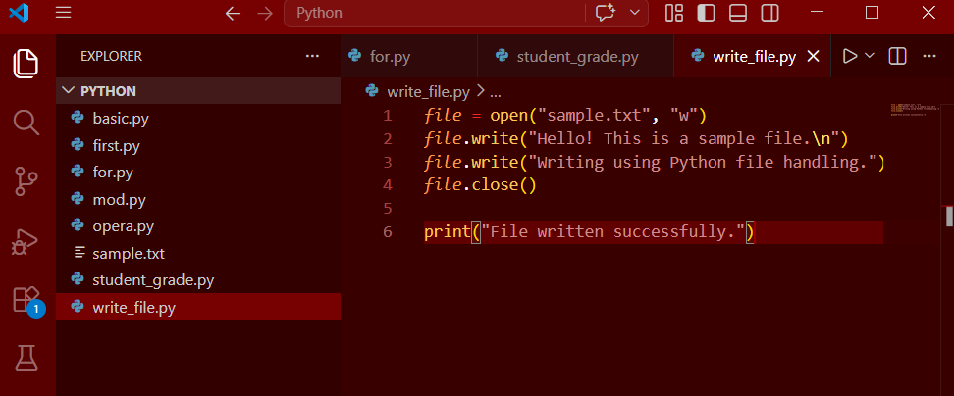

Output
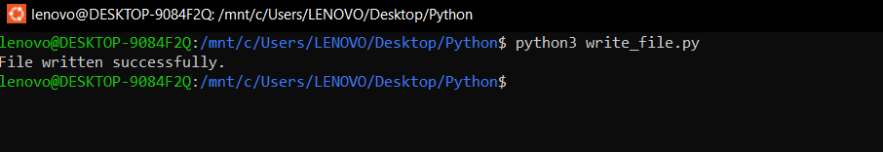

Explanation
This program demonstrates file handling in write mode ("w"). It creates a text file and writes content into it using the write() function. If the file does not exist, it is created automatically.

4.Read from a File
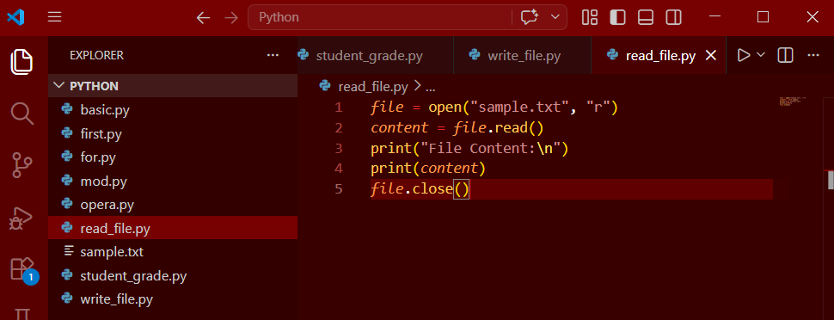
Output
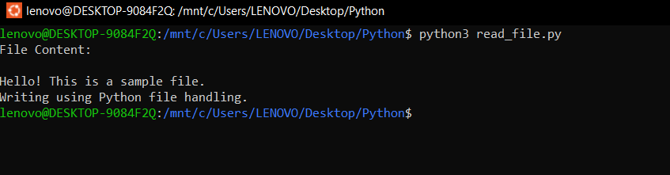

Explanation-

This program opens a file in read mode ("r") and uses the read() function to retrieve its contents. The content is then displayed on the screen.

